

**Faculty Of Engineering and Natural Sciences**

**Department of Electrical and Electronic Engineering**

**May 4, 2025**

**Integrating Large Language Models for Robot**

**Task Planning**

Almira Demirkıran 200202150

**E-mail:** almira.demirkiran@std.antalya.edu.tr

Mehmet Tosun 190202009

**E-mail:** mehmet.tosun@std.antalya.edu.tr

Abdallah Rasthy 200201125

**E-mail:** ali.rashty@std.antalya.edu.tr

Rustam Akhmedov 210201113

**E-mail:** rustam.akhmedov@std.antalya.edu.tr

**CONTENT**

**Robot Object Identification**

**Neural Network**

**Outside Token and Embedding**

**Fine-tuning**

**Introduction**

Interaction between man and machine plays an increasingly important role in modern industry. A good example is collaborative robotics. Collaborative robots participate in various tasks where manipulation of small parts or intricate motions are involved. This includes machine tending [[1](https://pmc.ncbi.nlm.nih.gov/articles/PMC7147712/#B1-sensors-20-01773)], assembly [[2](https://pmc.ncbi.nlm.nih.gov/articles/PMC7147712/#B2-sensors-20-01773)], painting [[3](https://pmc.ncbi.nlm.nih.gov/articles/PMC7147712/#B3-sensors-20-01773)], coating [[4](https://pmc.ncbi.nlm.nih.gov/articles/PMC7147712/#B4-sensors-20-01773)], and many others.

At the core of large language models are neural networks with multiple layers, known as deep learning models. These networks consist of interconnected nodes, or neurons, that learn to recognize patterns in the input data during the training phase. LLMs are trained on a massive body of text, encompassing diverse sources such as websites, books, and articles, allowing them to learn grammar, syntax, semantics, and contextual information.

**Robot Object Identification**

## Shape Recognition and Classification Methods

As stated by Hernández et al., the techniques and methods that detect objects depend on the application environment [[31](https://pmc.ncbi.nlm.nih.gov/articles/PMC7147712/#B31-sensors-20-01773)]. There are systems developed to work on mobile robots, performing navigation tasks and environment categorization, where accuracy is not the most important factor. The examples are systems for semantic navigation of mobile robots [[32](https://pmc.ncbi.nlm.nih.gov/articles/PMC7147712/#B32-sensors-20-01773),[33](https://pmc.ncbi.nlm.nih.gov/articles/PMC7147712/#B33-sensors-20-01773)]. Better recognition accuracy must be provided, e.g., by multisensory system for service robots used in automatic harvesting of fruits [[34](https://pmc.ncbi.nlm.nih.gov/articles/PMC7147712/#B34-sensors-20-01773)]. However, the highest requirements must be fulfilled by industrially-oriented systems. In order to properly classify the images of objects like workpieces and tools, even little details cannot be neglected. Admittedly, some industrially-oriented systems make use of basic geometric properties, such as area and moments of inertia only [[35](https://pmc.ncbi.nlm.nih.gov/articles/PMC7147712/#B35-sensors-20-01773)] or additionally contour perimeter and dimension of minimal enclosing circle [[28](https://pmc.ncbi.nlm.nih.gov/articles/PMC7147712/#B28-sensors-20-01773)]. However, such simple methods are sufficient only when a very narrow spectrum of strictly determined objects is expected. Generally, a detailed description of shape is needed to compare the objects with their templates.

There is a big number of shape representation techniques used in various image processing methods, generally divided into contour-based and region-based ones [[36](https://pmc.ncbi.nlm.nih.gov/articles/PMC7147712/#B36-sensors-20-01773)]. Contour-based techniques, include chain codes, polygon approximation, B-spline approximation, shape signature, Fourier descriptors, wavelet descriptors, and others. As far as region-based techniques are concerned, the geometric moments, moment invariants, Zernike moments, Legendre moments, convex hulls, and many others may be applied.

The chain codes describe contours by a sequence of unit-size line segments with given orientation. They can be used for image compression [[37](https://pmc.ncbi.nlm.nih.gov/articles/PMC7147712/#B37-sensors-20-01773)], recognition of monotonic parts in contours [[38](https://pmc.ncbi.nlm.nih.gov/articles/PMC7147712/#B38-sensors-20-01773)], and even for face recognition [[39](https://pmc.ncbi.nlm.nih.gov/articles/PMC7147712/#B39-sensors-20-01773)]. Contour discretization obtained by polygon approximation lets lower the computational cost in subsequent analysis [[40](https://pmc.ncbi.nlm.nih.gov/articles/PMC7147712/#B40-sensors-20-01773)]. An interesting research, dealing with polygon recognition, was presented by Hernandez et al. [[41](https://pmc.ncbi.nlm.nih.gov/articles/PMC7147712/#B41-sensors-20-01773)], used for identification of celestial bodies in the sky. For a more general shape analysis, B-spline approximation can be used. Application of B-splines involves miscellaneous areas. An example thereof is research presented by Pedrosa et al. [[42](https://pmc.ncbi.nlm.nih.gov/articles/PMC7147712/#B42-sensors-20-01773)]. They propose a framework for three-dimensional (3D)-ultrasound segmentation in cardiology. B-spline shape representation is sometimes used in shape design optimization task [[43](https://pmc.ncbi.nlm.nih.gov/articles/PMC7147712/#B43-sensors-20-01773)].

Shape signature represents a shape by one dimensional function (e.g., distance from centroid, tangent angle, curvature), derived from contour points [[36](https://pmc.ncbi.nlm.nih.gov/articles/PMC7147712/#B36-sensors-20-01773)]. Application of shape signature involves a very broad spectrum of domains like traffic sign recognition [[44](https://pmc.ncbi.nlm.nih.gov/articles/PMC7147712/#B44-sensors-20-01773)], recognition of facial expressions [[45](https://pmc.ncbi.nlm.nih.gov/articles/PMC7147712/#B45-sensors-20-01773)], detection of anaemia blood cells [[46](https://pmc.ncbi.nlm.nih.gov/articles/PMC7147712/#B46-sensors-20-01773)], classification and sorting of agricultural products [[47](https://pmc.ncbi.nlm.nih.gov/articles/PMC7147712/#B47-sensors-20-01773)].

Fourier descriptors constitute an important class of global invariant features based on algebraic properties of Fourier transform [[48](https://pmc.ncbi.nlm.nih.gov/articles/PMC7147712/#B48-sensors-20-01773)]. They are considered to be very promising descriptors as they have the advantages of computational efficiency and attractive invariance properties [[49](https://pmc.ncbi.nlm.nih.gov/articles/PMC7147712/#B49-sensors-20-01773)]. They may be applied to solve very challenging identification tasks, including analysis and classification of shapes encountered in nature: Blood cells [[50](https://pmc.ncbi.nlm.nih.gov/articles/PMC7147712/#B50-sensors-20-01773)] or leaves [[51](https://pmc.ncbi.nlm.nih.gov/articles/PMC7147712/#B51-sensors-20-01773)]. In the applications similar to the latter, even better classification accuracy may be obtained using wavelet descriptors [[52](https://pmc.ncbi.nlm.nih.gov/articles/PMC7147712/#B52-sensors-20-01773)].

An interesting contour recognition method is elastic matching (also known as deformable template). It is one of methods used in optical character recognition systems (OCR) [[53](https://pmc.ncbi.nlm.nih.gov/articles/PMC7147712/#B53-sensors-20-01773)]. Its basic idea is to optimally match the unknown symbol against all possible elastic stretching and compression of each prototype. Therefore, it is also one of methods used in handwritten character recognition [[54](https://pmc.ncbi.nlm.nih.gov/articles/PMC7147712/#B54-sensors-20-01773)]. An interesting application of this method was presented by Attalla and Siy [[55](https://pmc.ncbi.nlm.nih.gov/articles/PMC7147712/#B55-sensors-20-01773)] in their shape recognition algorithm where elastic matching was employed as an auxiliary method when the shapes were partially occluded.

Among region-based shape representation techniques, there are Zernike moments [[56](https://pmc.ncbi.nlm.nih.gov/articles/PMC7147712/#B56-sensors-20-01773)] and Legendre moments, both belonging to a family of orthogonal functions, which allow the generation of non-redundant descriptors by the projection of an image onto an orthogonal basis [[57](https://pmc.ncbi.nlm.nih.gov/articles/PMC7147712/#B57-sensors-20-01773)].

Convex hull of a region is the smallest convex region containing the region in question. Convex hulls are used for multiple purposes, e.g., image registration and retrieval, image classification, and shape detection [[58](https://pmc.ncbi.nlm.nih.gov/articles/PMC7147712/#B58-sensors-20-01773),[59](https://pmc.ncbi.nlm.nih.gov/articles/PMC7147712/#B59-sensors-20-01773)].

Unfortunately, all those methods are not suitable for domain of industrial collaborative robotics (except some simple cases). This domain is very specific. On the one hand, contours of workpieces or tools handled by industrial robots usually consist of quite simple segments like lines, arcs, and sometimes Bezier curves, unambiguously determined by small sets of numerical parameters. Therefore, there is no need to apply methods used for recognition of ambiguous, non-rigid, or fuzzy shapes encountered in the nature (e.g., methods based on Fourier descriptors). On the other hand, the objects belonging to the same class may significantly vary in shape. Good examples are contours of adjustable wrenches, shown in [Figure 1](https://pmc.ncbi.nlm.nih.gov/articles/PMC7147712/#sensors-20-01773-f001).

### Figure 1.

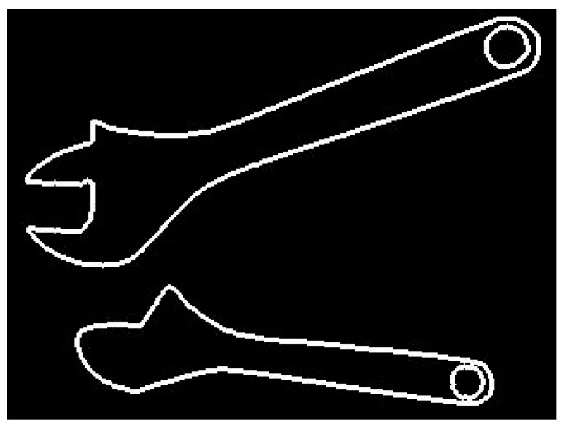

Shape differences between images of the same object.

The shape of adjustable wrench depends on how wide the wrench is open. Therefore, the use of methods, e.g., those based on signature matching, may lead to false classification (images of the same object would be classified to different groups). Seemingly, elastic matching may be a good solution. However, shape similarity between two workpieces or two tools does not necessarily indicate they belong to the same class. Also, the region-based methods, based on shape descriptors, may neglect small but critical differences in shape between objects belonging to different classes.

## **What are Neural Networks?**

Neural networks are computational models inspired by the human brain. They consist of interconnected layers of nodes (neurons) that process data and identify patterns. In the context of LLMs, neural networks help the model understand language by learning intricate relationships between words, phrases, and context.

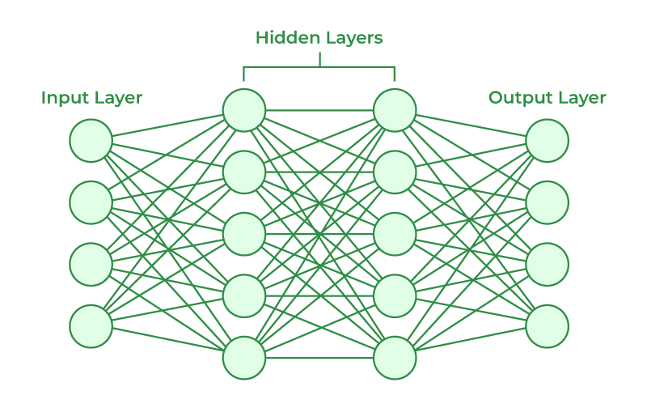

Simple representation of layers in a Neural Network

## **2. Layers in Neural Networks**

Neural networks used in LLMs are typically deep, meaning they have multiple layers:

* **Input Layer**: Takes in tokenized text data, such as word embeddings.
* **Hidden Layers**: Perform transformations on the input using weights and biases. These layers learn intermediate representations like context and relationships. Feedforward layers and Self-Attention Layers are hidden layers.
* **Feedforward Layers**: Pass information in one direction, from input to output.
* **Self-Attention Layers**: Crucial in transformers, these focus on relationships between words across a sentence.
* **Output Layer**: Generates predictions, such as the next word or probability distribution of possible tokens.

## **3. Backpropagation: How Neural Networks Learn**

Backpropagation is the training algorithm that enables neural networks to adjust and improve:

* **Forward Pass**: Data flows through the network, generating predictions.
* **Loss Function**: Compares predictions to actual labels (e.g., predicting the next word in a sentence). Common loss functions include Cross-Entropy Loss.

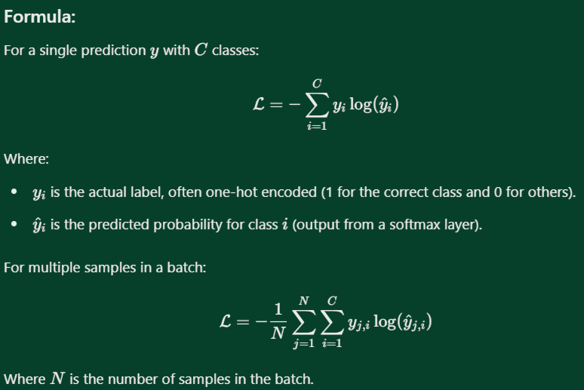

Cross Entropy Loss Formula

* **Backward Pass**: Calculates the gradient of the loss with respect to weights using calculus.
* **Gradient Descent**: Updates the weights to minimize the loss function iteratively, improving the model’s accuracy.

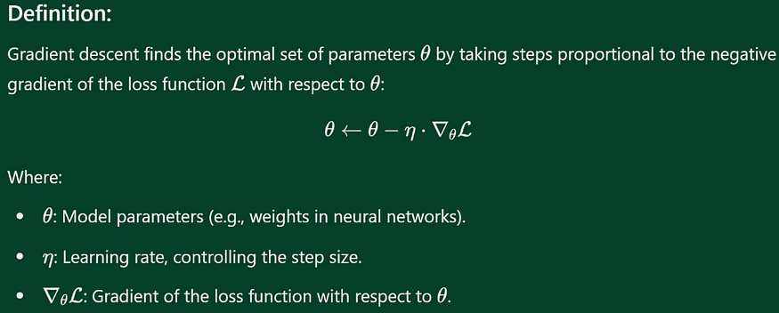

Gradient Descent Definition

## **4. Activation Functions: Introducing Non-Linearity**

Activation functions allow the network to learn complex, non-linear relationships. Popular activation functions include:

* **ReLU (Rectified Linear Unit)**: Efficiently handles large-scale networks by activating only positive values.

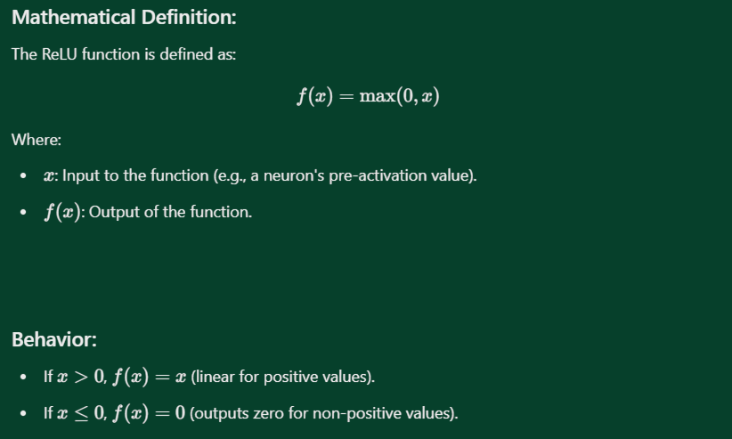

ReLU Definition and Behavior

* **Softmax**: Converts logits into probabilities, commonly used in the output layer for classification tasks.

*The****softmax activation function****is a mathematical function used in machine learning, particularly in classification problems and****large language models (LLMs)****, to convert raw model outputs (logits) into a probability distribution. It ensures that the outputs represent probabilities, which sum to 1.*

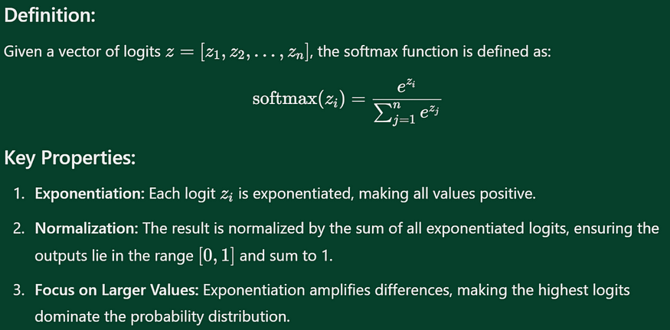

Softmax Definition

## **5. Why Deep Learning is Central to LLMs**

Deep learning enables LLMs to handle the vast complexity of language:

* **Feature Hierarchies**: Multiple layers allow the network to learn basic features like word meanings in earlier layers and advanced concepts like sentiment or tone in deeper layers.
* **Contextual Understanding**: Self-attention mechanisms within deep networks capture long-term dependencies, which are critical for understanding nuanced language.
* **Scalability**: Deep architectures like transformers handle massive datasets and billions of parameters, which are essential for training LLMs.

## **6. Specialized Neural Architectures for LLMs**

* **Feedforward Neural Networks**: Process individual tokens in embeddings.
* **Recurrent Neural Networks (RNNs)**: Used historically to handle sequences but struggle with long dependencies.

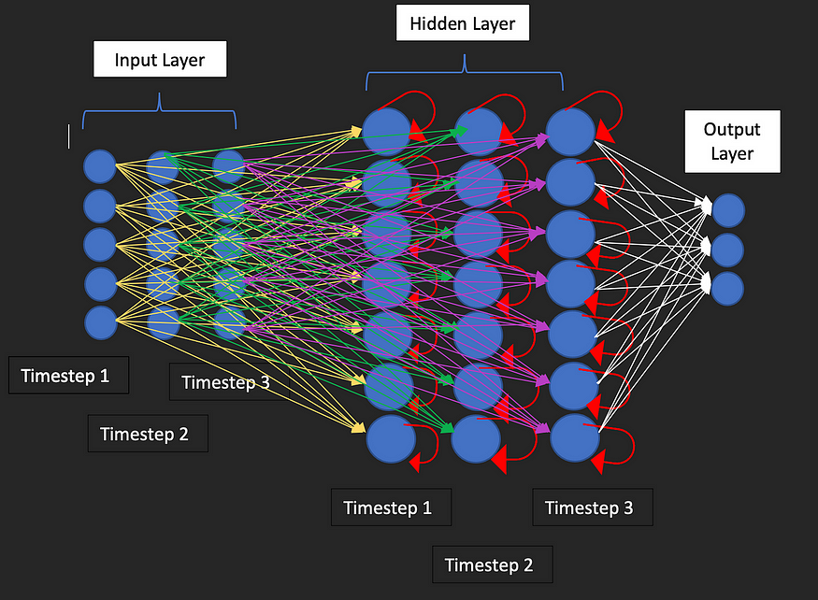

Recurrent Neural Network

* **Transformers**: The backbone of modern LLMs, leveraging self-attention to process text in parallel rather than sequentially.

How can machines read and understand texts?

For machines and NLP models like BERT or GPT to understand language, we need to represent written words as numbers (because computers only understand numbers).

Tokenization is the first step in natural language processing (NLP) projects. It involves dividing a text into individual units, known as tokens. Tokens can be words or punctuation marks. These tokens are then transformed into vectors, which are numerical representations of these words.

To give these tokens meaning, a deep learning model, often a transformer model, is trained on these vectors. This allows the model to understand the meaning of words and how they relate to each other.

The goal of this process is to enable NLP models to understand the meaning and semantics of different words and their context within a sentence or text.

Adrian Colyer explained this concept very nicely in his blog post “The amazing power of word vectors.”

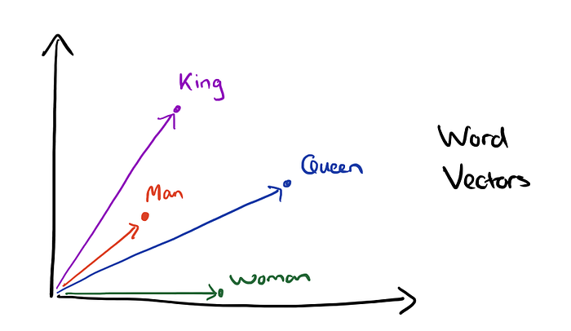

An example of word vectors and vector composition.

Source: Adrian Colyer. An example of word vectors and vector composition. Source: Adrian Colyer.

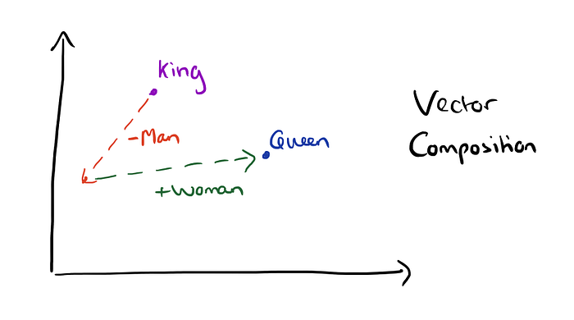

The vectors for the words “King” and “Man” may be similar, as might the vectors for “Queen” and “Woman.” These vectors also have certain properties that can be useful for training language models.

For example, you can subtract the vector for “Man” from the vector for “King” and add the vector for “Woman” to get the vector for “Queen.” These properties allow the model to understand the different meanings of words.

However, how does an NLP model determine which words are more similar to each other? This is because NLP models do not use a single number to represent a word. In fact, they often use more than 1,000 numbers to represent a single word.

This is why it is called a “word vector.” In mathematical terms, a single number is called a scalar, and a list of numbers is called a vector.

Example of different word vectors and their different dimensions. Source: Adrian Colyer.

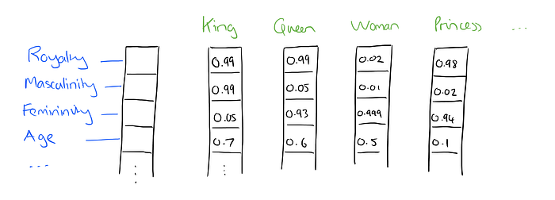

A word vector can be thought of as a point in a multi-dimensional space, where each dimension represents a particular aspect or characteristic of the word.

For example, a word vector for the word “queen” might have high values for dimensions representing “femininity” and “royalty” and low values for dimensions representing “masculinity.”

Combining all these dimensions makes up the vector for “queen,” which allows our model to understand the word’s meaning and how it relates to other words.

The number of dimensions in a word vector is often called “dimensionality.” A high-dimensional word vector would have many dimensions, allowing it to capture a wide range of characteristics and nuances of the word.

However, this also means that it would require more data and computation to train and use. On the other hand, a low-dimensional word vector would have fewer dimensions, making it simpler and more efficient to work with but potentially sacrificing some of the richness and detail of the word’s meaning.

An analogy for this concept might be trying to describe an object using different characteristics. For example, you might describe a ball as round, bouncy, and small.

Each of these characteristics could be considered a dimension in a word vector for the word “ball.” A high-dimensional word vector for “ball” might include dimensions for color, texture, shape, and function, while a low-dimensional word vector might only include dimensions for size and material.

## **What is Fine-Tuning?**

[Fine-tuning](https://www.techtarget.com/searchenterpriseai/definition/fine-tuning) is a technique in machine learning that focuses on specialized data, enhancing model performance for specific tasks while maintaining prior knowledge. This adaptability enables models to excel in new domains without losing their fundamental capabilities.

## **Stages in the Fine-Tuning Process**

Fine-tuning a machine learning model involves several stages, each contributing to the model’s adaptability and performance in a specific task:

### ***1. Selection of a Pre-Trained Model***

The first step is selecting an appropriate pre-trained model. This model, trained on a large dataset, serves as the starting point. The choice of model depends on the task at hand. For instance, one might choose ***BERT*** or ***GPT-3*** for NLP tasks, while selecting ***ResNet*** (Residual Network) or ***VGG*** for computer vision tasks.

### ***2. Data Preparation***

The next stage involves preparing the task-specific data. This data should be relevant to the task and properly labeled. It’s used to fine-tune the model, helping it adapt to the specific task.

### ***3. Model Adaptation***

In this stage, organizations adapt the pre-trained model using the task-specific data. Then they update the parameters of the model in this process to minimize the loss function. Typically, they perform this using optimization algorithms like stochastic gradient descent.

### ***4. Evaluation***

After fine-tuning, organizations evaluate the model on a validation set. This helps assess the model’s performance on the task. Metrics used for [evaluation](https://hyperight.com/evaluation-techniques-for-large-language-models-interview-with-rajiv-shah-hugging-face/) depend on the task – for instance, accuracy might be used for classification tasks, while BLEU (BiLingual Evaluation Understudy) score could be used for translation tasks.

### ***5. Iteration***

Fine-tuning is an iterative process. Based on the evaluation results, further fine-tuning might be needed to achieve optimal performance. This might involve adjusting hyperparameters, changing the optimization algorithm, or even selecting a different pre-trained model.

**References**

* 1.Pedersen M.R., Nalpantidis L., Andersen R.S., Schou C., Bøgh S., Krüger V., Madsen O. Robot skills for manufacturing: From concept to industrial deployment. Robot. Comput. Integr. Manuf. 2016;37:282–291. doi: 10.1016/j.rcim.2015.04.002. [[DOI](https://doi.org/10.1016/j.rcim.2015.04.002)] [[Google Scholar](https://scholar.google.com/scholar_lookup?journal=Robot.%20Comput.%20Integr.%20Manuf.&title=Robot%20skills%20for%20manufacturing:%20From%20concept%20to%20industrial%20deployment&author=M.R.%20Pedersen&author=L.%20Nalpantidis&author=R.S.%20Andersen&author=C.%20Schou&author=S.%20B%C3%B8gh&volume=37&publication_year=2016&pages=282-291&doi=10.1016/j.rcim.2015.04.002&)]
* 2.Dalle Mura M., Dini G. Designing assembly lines with humans and collaborative robots: A genetic approach. CIRP Ann. 2019;68:1–4. doi: 10.1016/j.cirp.2019.04.006. [[DOI](https://doi.org/10.1016/j.cirp.2019.04.006)] [[Google Scholar](https://scholar.google.com/scholar_lookup?journal=CIRP%20Ann.&title=Designing%20assembly%20lines%20with%20humans%20and%20collaborative%20robots:%20A%20genetic%20approach&author=M.%20Dalle%20Mura&author=G.%20Dini&volume=68&publication_year=2019&pages=1-4&doi=10.1016/j.cirp.2019.04.006&)]
* 3.Asadi E., Li B., Chen I.M. Pictobot: A Cooperative Painting Robot for Interior Finishing of Industrial Developments. IEEE Robot. Autom. Mag. 2018;25:82–94. doi: 10.1109/MRA.2018.2816972. [[DOI](https://doi.org/10.1109/MRA.2018.2816972)] [[Google Scholar](https://scholar.google.com/scholar_lookup?journal=IEEE%20Robot.%20Autom.%20Mag.&title=Pictobot:%20A%20Cooperative%20Painting%20Robot%20for%20Interior%20Finishing%20of%20Industrial%20Developments&author=E.%20Asadi&author=B.%20Li&author=I.M.%20Chen&volume=25&publication_year=2018&pages=82-94&doi=10.1109/MRA.2018.2816972&)]
* 4.Chmielewski T., Hudycz M., Krajewski A., Salaciński T., Skowrońska B., Świercz R. Structure investigation of titanium metallization coating deposited onto aln ceramics substrate by means of friction surfacing process. Coatings. 2019;9:845. doi: 10.3390/coatings9120845. [[DOI](https://doi.org/10.3390/coatings9120845)] [[Google Scholar](https://scholar.google.com/scholar_lookup?journal=Coatings&title=Structure%20investigation%20of%20titanium%20metallization%20coating%20deposited%20onto%20aln%20ceramics%20substrate%20by%20means%20of%20friction%20surfacing%20process&author=T.%20Chmielewski&author=M.%20Hudycz&author=A.%20Krajewski&author=T.%20Salaci%C5%84ski&author=B.%20Skowro%C5%84ska&volume=9&publication_year=2019&pages=845&doi=10.3390/coatings9120845&)]
* 28.Tasevski J., Nikolić M., Mišković D. Integration of an Industrial Robot with the Systems for Image and Voice Recognition. SERBIAN J. Electr. Eng. 2013;10:219–230. doi: 10.2298/SJEE1301219T. [[DOI](https://doi.org/10.2298/SJEE1301219T)] [[Google Scholar](https://scholar.google.com/scholar_lookup?journal=SERBIAN%20J.%20Electr.%20Eng.&title=Integration%20of%20an%20Industrial%20Robot%20with%20the%20Systems%20for%20Image%20and%20Voice%20Recognition&author=J.%20Tasevski&author=M.%20Nikoli%C4%87&author=D.%20Mi%C5%A1kovi%C4%87&volume=10&publication_year=2013&pages=219-230&doi=10.2298/SJEE1301219T&)]
* 31.Hernández A.C., Gómez C., Crespo J., Barber R. Object detection applied to indoor environments for mobile robot navigation. Sensors. 2016;16:1180. doi: 10.3390/s16081180. [[DOI](https://doi.org/10.3390/s16081180)] [[PMC free article](https://pmc.ncbi.nlm.nih.gov/articles/PMC5017346/)] [[PubMed](https://pubmed.ncbi.nlm.nih.gov/27483264/)] [[Google Scholar](https://scholar.google.com/scholar_lookup?journal=Sensors&title=Object%20detection%20applied%20to%20indoor%20environments%20for%20mobile%20robot%20navigation&author=A.C.%20Hern%C3%A1ndez&author=C.%20G%C3%B3mez&author=J.%20Crespo&author=R.%20Barber&volume=16&publication_year=2016&pages=1180&pmid=27483264&doi=10.3390/s16081180&)]
* 32.Crespo J., Gómez C., Hernández A., Barber R. A semantic labeling of the environment based on what people do. Sensors. 2017;17:260. doi: 10.3390/s17020260. [[DOI](https://doi.org/10.3390/s17020260)] [[PMC free article](https://pmc.ncbi.nlm.nih.gov/articles/PMC5336130/)] [[PubMed](https://pubmed.ncbi.nlm.nih.gov/28146049/)] [[Google Scholar](https://scholar.google.com/scholar_lookup?journal=Sensors&title=A%20semantic%20labeling%20of%20the%20environment%20based%20on%20what%20people%20do&author=J.%20Crespo&author=C.%20G%C3%B3mez&author=A.%20Hern%C3%A1ndez&author=R.%20Barber&volume=17&publication_year=2017&pages=260&pmid=28146049&doi=10.3390/s17020260&)]
* 33.Astua C., Barber R., Crespo J., Jardon A. Object detection techniques applied on mobile robot semantic navigation. Sensors. 2014;14:6734–6757. doi: 10.3390/s140406734. [[DOI](https://doi.org/10.3390/s140406734)] [[PMC free article](https://pmc.ncbi.nlm.nih.gov/articles/PMC4029636/)] [[PubMed](https://pubmed.ncbi.nlm.nih.gov/24732101/)] [[Google Scholar](https://scholar.google.com/scholar_lookup?journal=Sensors&title=Object%20detection%20techniques%20applied%20on%20mobile%20robot%20semantic%20navigation&author=C.%20Astua&author=R.%20Barber&author=J.%20Crespo&author=A.%20Jardon&volume=14&publication_year=2014&pages=6734-6757&pmid=24732101&doi=10.3390/s140406734&)]
* 34.Fernández R., Salinas C., Montes H., Sarria J. Multisensory system for fruit harvesting robots. Experimental testing in natural scenarios and with different kinds of crops. Sensors. 2014;14:23885–23904. doi: 10.3390/s141223885. [[DOI](https://doi.org/10.3390/s141223885)] [[PMC free article](https://pmc.ncbi.nlm.nih.gov/articles/PMC4299092/)] [[PubMed](https://pubmed.ncbi.nlm.nih.gov/25615730/)] [[Google Scholar](https://scholar.google.com/scholar_lookup?journal=Sensors&title=Multisensory%20system%20for%20fruit%20harvesting%20robots.%20Experimental%20testing%20in%20natural%20scenarios%20and%20with%20different%20kinds%20of%20crops&author=R.%20Fern%C3%A1ndez&author=C.%20Salinas&author=H.%20Montes&author=J.%20Sarria&volume=14&publication_year=2014&pages=23885-23904&pmid=25615730&doi=10.3390/s141223885&)]
* 35.Rogowski A. Remote programming and control of the flexible machining cell. Int. J. Comput. Integr. Manuf. 2015;28:650–663. doi: 10.1080/0951192X.2014.900862. [[DOI](https://doi.org/10.1080/0951192X.2014.900862)] [[Google Scholar](https://scholar.google.com/scholar_lookup?journal=Int.%20J.%20Comput.%20Integr.%20Manuf.&title=Remote%20programming%20and%20control%20of%20the%20flexible%20machining%20cell&author=A.%20Rogowski&volume=28&publication_year=2015&pages=650-663&doi=10.1080/0951192X.2014.900862&)]
* 36.Zhang D., Lu G. Review of shape representation and description techniques. Pattern Recognit. 2004;37:1–19. doi: 10.1016/j.patcog.2003.07.008. [[DOI](https://doi.org/10.1016/j.patcog.2003.07.008)] [[Google Scholar](https://scholar.google.com/scholar_lookup?journal=Pattern%20Recognit.&title=Review%20of%20shape%20representation%20and%20description%20techniques&author=D.%20Zhang&author=G.%20Lu&volume=37&publication_year=2004&pages=1-19&doi=10.1016/j.patcog.2003.07.008&)]
* 37.Žalik B., Mongus D., Žalik K.R., Lukač N. Digital Signal Processing Chain code compression using string transformation techniques. Digit. Signal Process. 2016;53:1–10. doi: 10.1016/j.dsp.2016.03.002. [[DOI](https://doi.org/10.1016/j.dsp.2016.03.002)] [[Google Scholar](https://scholar.google.com/scholar_lookup?journal=Digit.%20Signal%20Process.&title=Digital%20Signal%20Processing%20Chain%20code%20compression%20using%20string%20transformation%20techniques&author=B.%20%C5%BDalik&author=D.%20Mongus&author=K.R.%20%C5%BDalik&author=N.%20Luka%C4%8D&volume=53&publication_year=2016&pages=1-10&doi=10.1016/j.dsp.2016.03.002&)]
* 38.Žalik B., Mongus D., Liu Y.-K., Lukač N. Unsigned Manhattan chain code. J. Vis. Commun. Image Represent. 2016;38:186–194. doi: 10.1016/j.jvcir.2016.03.001. [[DOI](https://doi.org/10.1016/j.jvcir.2016.03.001)] [[Google Scholar](https://scholar.google.com/scholar_lookup?journal=J.%20Vis.%20Commun.%20Image%20Represent.&title=Unsigned%20Manhattan%20chain%20code&author=B.%20%C5%BDalik&author=D.%20Mongus&author=Y.-K.%20Liu&author=N.%20Luka%C4%8D&volume=38&publication_year=2016&pages=186-194&doi=10.1016/j.jvcir.2016.03.001&)]
* 39.Karczmarek P., Kiersztyn A., Pedrycz W., Dolecki M. An application of chain code-based local descriptor and its extension to face recognition. Pattern Recognit. 2017;65:26–34. doi: 10.1016/j.patcog.2016.12.008. [[DOI](https://doi.org/10.1016/j.patcog.2016.12.008)] [[Google Scholar](https://scholar.google.com/scholar_lookup?journal=Pattern%20Recognit.&title=An%20application%20of%20chain%20code-based%20local%20descriptor%20and%20its%20extension%20to%20face%20recognition&author=P.%20Karczmarek&author=A.%20Kiersztyn&author=W.%20Pedrycz&author=M.%20Dolecki&volume=65&publication_year=2017&pages=26-34&doi=10.1016/j.patcog.2016.12.008&)]
* 40.Prematilake C., Ellingson L. Evaluation and prediction of polygon approximations of planar contours for shape analysis. J. Appl. Stat. 2018;45:1227–1246. doi: 10.1080/02664763.2017.1364716. [[DOI](https://doi.org/10.1080/02664763.2017.1364716)] [[Google Scholar](https://scholar.google.com/scholar_lookup?journal=J.%20Appl.%20Stat.&title=Evaluation%20and%20prediction%20of%20polygon%20approximations%20of%20planar%20contours%20for%20shape%20analysis&author=C.%20Prematilake&author=L.%20Ellingson&volume=45&publication_year=2018&pages=1227-1246&doi=10.1080/02664763.2017.1364716&)]
* 41.Hernández A.E., Alonso M.A., Chávez E., Covarrubias D.H., Conte R. Robust polygon recognition method with similarity invariants applied to star identification. Adv. Sp. Res. 2017;59:1095–1111. doi: 10.1016/j.asr.2016.11.016. [[DOI](https://doi.org/10.1016/j.asr.2016.11.016)] [[Google Scholar](https://scholar.google.com/scholar_lookup?journal=Adv.%20Sp.%20Res.&title=Robust%20polygon%20recognition%20method%20with%20similarity%20invariants%20applied%20to%20star%20identification&author=A.E.%20Hern%C3%A1ndez&author=M.A.%20Alonso&author=E.%20Ch%C3%A1vez&author=D.H.%20Covarrubias&author=R.%20Conte&volume=59&publication_year=2017&pages=1095-1111&doi=10.1016/j.asr.2016.11.016&)]
* 42.Pedrosa J., Queiros S., Bernard O., Engvall J., Edvardsen T., Nagel E., D’Hooge J. Fast and Fully Automatic Left Ventricular Segmentation and Tracking in Echocardiography Using Shape-Based B-Spline Explicit Active Surfaces. IEEE Trans. Med. Imaging. 2017;36:2287–2296. doi: 10.1109/TMI.2017.2734959. [[DOI](https://doi.org/10.1109/TMI.2017.2734959)] [[PubMed](https://pubmed.ncbi.nlm.nih.gov/28783626/)] [[Google Scholar](https://scholar.google.com/scholar_lookup?journal=IEEE%20Trans.%20Med.%20Imaging&title=Fast%20and%20Fully%20Automatic%20Left%20Ventricular%20Segmentation%20and%20Tracking%20in%20Echocardiography%20Using%20Shape-Based%20B-Spline%20Explicit%20Active%20Surfaces&author=J.%20Pedrosa&author=S.%20Queiros&author=O.%20Bernard&author=J.%20Engvall&author=T.%20Edvardsen&volume=36&publication_year=2017&pages=2287-2296&pmid=28783626&doi=10.1109/TMI.2017.2734959&)]
* 43.Yang Z., Sendhoff B., Tang K., Yao X. Target shape design optimization by evolving B-splines with cooperative coevolution. Appl. Soft Comput. 2016;48:672–682. doi: 10.1016/j.asoc.2016.07.027. [[DOI](https://doi.org/10.1016/j.asoc.2016.07.027)] [[Google Scholar](https://scholar.google.com/scholar_lookup?journal=Appl.%20Soft%20Comput.&title=Target%20shape%20design%20optimization%20by%20evolving%20B-splines%20with%20cooperative%20coevolution&author=Z.%20Yang&author=B.%20Sendhoff&author=K.%20Tang&author=X.%20Yao&volume=48&publication_year=2016&pages=672-682&doi=10.1016/j.asoc.2016.07.027&)]
* 44.Cai Z.X., Gu M.Q. Traffic sign recognition algorithm based on shape signature and dual-tree complex wavelet transform. J. Cent. South Univ. 2013;20:433–439. doi: 10.1007/s11771-013-1504-0. [[DOI](https://doi.org/10.1007/s11771-013-1504-0)] [[Google Scholar](https://scholar.google.com/scholar_lookup?journal=J.%20Cent.%20South%20Univ.&title=Traffic%20sign%20recognition%20algorithm%20based%20on%20shape%20signature%20and%20dual-tree%20complex%20wavelet%20transform&author=Z.X.%20Cai&author=M.Q.%20Gu&volume=20&publication_year=2013&pages=433-439&doi=10.1007/s11771-013-1504-0&)]
* 45.Barman A., Dutta P. Facial expression recognition using distance and shape signature features. Pattern Recognit. Lett. 2017:1–8. doi: 10.1016/j.patrec.2017.06.018. [[DOI](https://doi.org/10.1016/j.patrec.2017.06.018)] [[Google Scholar](https://scholar.google.com/scholar_lookup?journal=Pattern%20Recognit.%20Lett.&title=Facial%20expression%20recognition%20using%20distance%20and%20shape%20signature%20features&author=A.%20Barman&author=P.%20Dutta&publication_year=2017&pages=1-8&doi=10.1016/j.patrec.2017.06.018&)]
* 46.Elsalamony H.A. Anaemia cells detection based on shape signature using neural networks. Meas. J. Int. Meas. Confed. 2017;104:50–59. doi: 10.1016/j.measurement.2017.03.012. [[DOI](https://doi.org/10.1016/j.measurement.2017.03.012)] [[Google Scholar](https://scholar.google.com/scholar_lookup?journal=Meas.%20J.%20Int.%20Meas.%20Confed.&title=Anaemia%20cells%20detection%20based%20on%20shape%20signature%20using%20neural%20networks&author=H.A.%20Elsalamony&volume=104&publication_year=2017&pages=50-59&doi=10.1016/j.measurement.2017.03.012&)]
* 47.Moreda G.P., Muñoz M.A., Ruiz-Altisent M., Perdigones A. Shape determination of horticultural produce using two-dimensional computer vision - A review. J. Food Eng. 2012;108:245–261. doi: 10.1016/j.jfoodeng.2011.08.011. [[DOI](https://doi.org/10.1016/j.jfoodeng.2011.08.011)] [[Google Scholar](https://scholar.google.com/scholar_lookup?journal=J.%20Food%20Eng.&title=Shape%20determination%20of%20horticultural%20produce%20using%20two-dimensional%20computer%20vision%20-%20A%20review&author=G.P.%20Moreda&author=M.A.%20Mu%C3%B1oz&author=M.%20Ruiz-Altisent&author=A.%20Perdigones&volume=108&publication_year=2012&pages=245-261&doi=10.1016/j.jfoodeng.2011.08.011&)]
* 48.Bohi A., Prandi D., Guis V., Bouchara F., Gauthier J.-P. Fourier Descriptors Based on the Structure of the Human Primary Visual Cortex with Applications to Object Recognition. J. Math. Imaging Vis. 2017;57:117–133. doi: 10.1007/s10851-016-0669-1. [[DOI](https://doi.org/10.1007/s10851-016-0669-1)] [[Google Scholar](https://scholar.google.com/scholar_lookup?journal=J.%20Math.%20Imaging%20Vis.&title=Fourier%20Descriptors%20Based%20on%20the%20Structure%20of%20the%20Human%20Primary%20Visual%20Cortex%20with%20Applications%20to%20Object%20Recognition&author=A.%20Bohi&author=D.%20Prandi&author=V.%20Guis&author=F.%20Bouchara&author=J.-P.%20Gauthier&volume=57&publication_year=2017&pages=117-133&doi=10.1007/s10851-016-0669-1&)]
* 49.El-Ghazal A., Basir O., Belkasim S. Invariant curvature-based Fourier shape descriptors. J. Vis. Commun. Image Represent. 2012;23:622–633. doi: 10.1016/j.jvcir.2012.01.011. [[DOI](https://doi.org/10.1016/j.jvcir.2012.01.011)] [[Google Scholar](https://scholar.google.com/scholar_lookup?journal=J.%20Vis.%20Commun.%20Image%20Represent.&title=Invariant%20curvature-based%20Fourier%20shape%20descriptors&author=A.%20El-Ghazal&author=O.%20Basir&author=S.%20Belkasim&volume=23&publication_year=2012&pages=622-633&doi=10.1016/j.jvcir.2012.01.011&)]
* 50.Tomakova R., Komkov V., Emelianov E., Tomakov M. The Use of Fourier Descriptors for the Classification and Analysis of Peripheral Blood Smears Image. Appl. Math. 2017;8:1563–1571. doi: 10.4236/am.2017.811114. [[DOI](https://doi.org/10.4236/am.2017.811114)] [[Google Scholar](https://scholar.google.com/scholar_lookup?journal=Appl.%20Math.&title=The%20Use%20of%20Fourier%20Descriptors%20for%20the%20Classification%20and%20Analysis%20of%20Peripheral%20Blood%20Smears%20Image&author=R.%20Tomakova&author=V.%20Komkov&author=E.%20Emelianov&author=M.%20Tomakov&volume=8&publication_year=2017&pages=1563-1571&doi=10.4236/am.2017.811114&)]
* 51.Kadir A. Leaf Identification Using Fourier Descriptors and Other Shape Features. Gate to Comput. Vis. Pattern Recognit. 2015;1:3–7. doi: 10.15579/gtcvpr.0101.003007. [[DOI](https://doi.org/10.15579/gtcvpr.0101.003007)] [[Google Scholar](https://scholar.google.com/scholar_lookup?journal=Gate%20to%20Comput.%20Vis.%20Pattern%20Recognit.&title=Leaf%20Identification%20Using%20Fourier%20Descriptors%20and%20Other%20Shape%20Features&author=A.%20Kadir&volume=1&publication_year=2015&pages=3-7&doi=10.15579/gtcvpr.0101.003007&)]
* 52.Yousefi E., Baleghi Y., Mahmoud Sakhaei S. Rotation invariant wavelet descriptors, a new set of features to enhance plant leaves classification. Comput. Electron. Agric. 2017;140:70–76. doi: 10.1016/j.compag.2017.05.031. [[DOI](https://doi.org/10.1016/j.compag.2017.05.031)] [[Google Scholar](https://scholar.google.com/scholar_lookup?journal=Comput.%20Electron.%20Agric.&title=Rotation%20invariant%20wavelet%20descriptors,%20a%20new%20set%20of%20features%20to%20enhance%20plant%20leaves%20classification&author=E.%20Yousefi&author=Y.%20Baleghi&author=S.%20Mahmoud%20Sakhaei&volume=140&publication_year=2017&pages=70-76&doi=10.1016/j.compag.2017.05.031&)]
* 53.Chaudhuri A., Mandaviya K., Badelia P., K Ghosh S. Optical Character Recognition Systems for Different Languages with Soft Computing. Volume 352. Springer International Publishing; Cham, Switzerland: 2017. Studies in Fuzziness and Soft Computing. [[Google Scholar](https://scholar.google.com/scholar_lookup?title=Optical%20Character%20Recognition%20Systems%20for%20Different%20Languages%20with%20Soft%20Computing&author=A.%20Chaudhuri&author=K.%20Mandaviya&author=P.%20Badelia&author=S.%20K%20Ghosh&publication_year=2017&isbn=978-3-319-50251-9&)]
* 54.Impedovo S. More than twenty years of advancements on frontiers in handwriting recognition. Pattern Recognit. 2014;47:916–928. doi: 10.1016/j.patcog.2013.05.027. [[DOI](https://doi.org/10.1016/j.patcog.2013.05.027)] [[Google Scholar](https://scholar.google.com/scholar_lookup?journal=Pattern%20Recognit.&title=More%20than%20twenty%20years%20of%20advancements%20on%20frontiers%20in%20handwriting%20recognition&author=S.%20Impedovo&volume=47&publication_year=2014&pages=916-928&doi=10.1016/j.patcog.2013.05.027&)]
* 55.Attalla E., Siy P. Robust shape similarity retrieval based on contour segmentation polygonal multiresolution and elastic matching. Pattern Recognit. 2005;38:2229–2241. doi: 10.1016/j.patcog.2005.02.009. [[DOI](https://doi.org/10.1016/j.patcog.2005.02.009)] [[Google Scholar](https://scholar.google.com/scholar_lookup?journal=Pattern%20Recognit.&title=Robust%20shape%20similarity%20retrieval%20based%20on%20contour%20segmentation%20polygonal%20multiresolution%20and%20elastic%20matching&author=E.%20Attalla&author=P.%20Siy&volume=38&publication_year=2005&pages=2229-2241&doi=10.1016/j.patcog.2005.02.009&)]
* 56.Li S., Lee M.C., Pun C.M. Complex Zernike moments features for shape-based image retrieval. IEEE Trans. Syst. Man Cybern. Part A Syst. Hum. 2009;39:227–237. doi: 10.1109/TSMCA.2008.2007988. [[DOI](https://doi.org/10.1109/TSMCA.2008.2007988)] [[Google Scholar](https://scholar.google.com/scholar_lookup?journal=IEEE%20Trans.%20Syst.%20Man%20Cybern.%20Part%20A%20Syst.%20Hum.&title=Complex%20Zernike%20moments%20features%20for%20shape-based%20image%20retrieval&author=S.%20Li&author=M.C.%20Lee&author=C.M.%20Pun&volume=39&publication_year=2009&pages=227-237&doi=10.1109/TSMCA.2008.2007988&)]
* 57.Hamdan B., Mokhtar K. Face recognition using Angular Radial Transform. J. King Saud Univ. Comput. Inf. Sci. 2018;30:141–151. doi: 10.1016/j.jksuci.2016.10.006. [[DOI](https://doi.org/10.1016/j.jksuci.2016.10.006)] [[Google Scholar](https://scholar.google.com/scholar_lookup?journal=J.%20King%20Saud%20Univ.%20Comput.%20Inf.%20Sci.&title=Face%20recognition%20using%20Angular%20Radial%20Transform&author=B.%20Hamdan&author=K.%20Mokhtar&volume=30&publication_year=2018&pages=141-151&doi=10.1016/j.jksuci.2016.10.006&)]
* 58.Jayaram M.A., Fleyeh H. Convex Hulls in Image Processing: A Scoping Review. Am. J. Intell. Syst. 2016;6:48–58. [[Google Scholar](https://scholar.google.com/scholar_lookup?journal=Am.%20J.%20Intell.%20Syst.&title=Convex%20Hulls%20in%20Image%20Processing:%20A%20Scoping%20Review&author=M.A.%20Jayaram&author=H.%20Fleyeh&volume=6&publication_year=2016&pages=48-58&)]
* 59.Igarashi Y., Suzuki H. Cover geometry design using multiple convex hulls. Comput. Des. 2011;43:1154–1162. doi: 10.1016/j.cad.2011.04.016. [[DOI](https://doi.org/10.1016/j.cad.2011.04.016)] [[Google Scholar](https://scholar.google.com/scholar_lookup?journal=Comput.%20Des.&title=Cover%20geometry%20design%20using%20multiple%20convex%20hulls&author=Y.%20Igarashi&author=H.%20Suzuki&volume=43&publication_year=2011&pages=1154-1162&doi=10.1016/j.cad.2011.04.016&)]